R.983
27 May 1994

as amended by

R.120 of 06/02/2004
R.278 of 24/03/2005
R.71 of 27/01/2006
R.72 of 27/01/2006
R.50 of 26/01/2007
R.1236 of 20/12/2007
R.241 of 2009 (G.G. 31974 of 05/03/2009)
R.268 of 2010 (G.G. 33085 of 20/04/2010)
R.150 of 2011 (G.G. 34041 of 23/02/2011)
R.197 of 2013 (G.G. 36254 of 15/03/2013)
R.268 of 2014 (G.G. 37510 of 04/04/2014)
R.358 of 2014 (G.G. 37629 of 13/05/2014)
R.385 of 2015 (G.G. 38769 of 15/05/2015)
R.444 of 2016 (G.G. 39928 of 15/04/2016)
R.117 of 2017 (G.G. 40612 of 10/02/2017)
R.379 of 2018 (G.G. 41529 of 27/03/2018)

RULES, FORMS AND PARTICULARS WHICH SHALL BE FURNISHED IN TERMS OF THE COMPENSATION FOR OCCUPATIONAL INJURIES AND DISEASES ACT, 1993 (Act NO. 130 OF 1993)

I, Louis van Assen, Compensation Commissioner, hereby prescribe under section 4(2)(e) of the Occupational Injuries and Diseases Act, 1993 (Act No. 130 of 1993), the following:

1. Application for Increased Compensation (section 56)

An application for increased compensation shall be submitted to the Commissioner on Form WG 30 (Annexure 1) with the particulars required therein and such other information and documents as the applicant may consider necessary.

Rules to facilitate the consideration of applications under section 56.

In these rules a word or expression to which a meaning has been assigned in the Act shall have that meaning and, unless the context indicates otherwise -

"applicant" means the person making application;

"applications" means an application in terms of section 56 of the Act for increased compensation;

"the act" the Compensation for Occupational Injuries and Diseases Act, 1993 (Act No. 130 of 1993), and also the Workmen's Compensation Act, 1941 (Act No. 30 of 1941);

"respondent" means -
(a) in the cases where the compensation fund is liable for the payment of compensation -
(i) the legal officer or any other person appointed by the Commissioner; and
(ii) as second respondent, the employer of the employee concerned unless the said employer has notified the Commissioner that he does not intend to intervene in the matter or fails to comply with paragraph (f) of these rules;
(b) in the case where a mutual association is liable for the payment of compensation -
(i) the mutual association: and
(ii) as second respondent, the employer of the employee concerned unless the said employer has notified the commissioner that he does not intent to intervene in the matter or has failed to comply with paragraph (f) of these rules;
(c) in the case where an employer referred to in section 84(1)(a)(i) of the Act is liable for the payment of compensation, the person concerned mentioned in section 39(2) of the Act;
(d) in any other case where an employer individually liable for the payment of compensation, such employer.
(e) The Commissioner shall as soon as practicable after an application has been submitted to send a copy thereof to the employer in question and, where appropriate, the mutual association.
(f) Within three months after a copy has been sent, every respondent shall deliver a document to the Commissioner and the applicant in which he states -
(i) whether he contests the application and, if so,
(ii) which allegations by the applicant he admits and which allegations he denies, together with such explanations and information that he may deem relevant.
(g) The applicant shall within three months after the document referred to in paragraph (f) has been delivered to him deliver a document to the Commissioner and every respondent in which he states -
(i) whether he intends to proceed with his application and, if so,
(ii) which allegations by the respondent he admits and which allegations he denies, together with such information that he may deem relevant.
(h) The Commissioner may at any time request any party to supply further particulars and such party shall within the period determined by the Commissioner deliver a document with such particulars to the Commissioner. The Commissioner may at any time permit any party to amend or supplement any allegation, explanation or information in terms of paragraphs (f), (g) or (h) of these rules.
(j) The Commissioner may at any time extend the period prescribed by paragraphs (f), (g) or determined in terms of paragraph (h) of these rules.
(k) If the Commissioner decides upon a formal hearing, he shall send a document to every party in which -
(i) he sets out the facts which have been admitted and for which there is prima facie evidence in his opinion;
(ii) he formulates the issue.
(l) The Commissioner may at any time before or during the hearing of his own accord or on application by one of the parties amend the formulation of the issue.
(m) A formal hearing shall not be set down or be proceeded with earlier than 30 days after the dispatch of the documents referred to in paragraph (k) of these rules or the amendment of the formulation of the issue as contemplated in paragraph (l) save with the consent of all the parties.

3. Return of Earnings (section 82(1)) (After Changes)

The Return of Earnings shall be on Form W.As. 8 [AnnexureA] with the particulars required therein, as the case maybe.

[Item 3 amended by R.94 of 27/01/95 and by R.1918 of 22/11/96 and by R.303 of 28/02/2003 and by R.50 of 26/01/2007 and by R.1236 of 20/12/2007 and by R.241 of 2009 and by R.268 of 2010 and replaced by R.150 of 2011 and by R.197 of 2013 and by R.444 of 2016, replaced byR.379 of 2018]

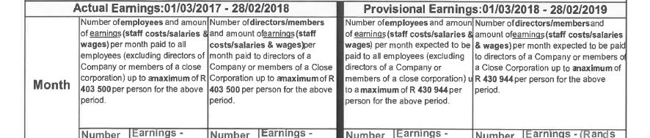
COST CHANGES

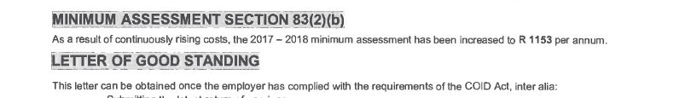
Previous costs were R355 752 per annum.

Previous costs were R1000 per annum.

